**Writing Portfolio**

**Michelle Wu**

W6A

Summer Writing Course

With Mr. J at Teachall

July-August 2020, Beijing

**Index**

**I**

**Essays**

1. Essay 1: My Crazy Day

2. Essay 2: Making a Claim About a Historical Event

3. Essay 3: Using Variety When Introducing Narrator’s Thoughts

(Picture: Story Arc)

4. Essay 4: Narrative Writing Exercise

(Picture: Story Arc)

5. Essay 5: Writing from the Point of View of a Fictional Character

(Picture: Story Arc)

6. Essay 6: Analyzing Literature: Noticing the Author’s Choices in “How the Leopard Got His Spots” by Rudyard Kipling

(Picture: Story Arc)

7. Essay 7: Narrative Worksheet: Short Story

8. Essay 8: Letter to Captain

**II**

**Journal Entries**

1. Do you enjoy writing? Why or why not?

2. What is the one thing that you want to change about yourself?

3. What unexpected thing happened to you recently? Why?

4. What are three reasons why the global pandemic is good?

5. Write a 200-300 word summary of the article using at least three direct quotes.

6. Write your opinion of the situation. Do you agree or disagree with the writer? Why?

7. What character traits are most important to you? Why?

8. Why do some people struggle to do the right thing?

9. What does it mean to have integrity?

10. What is the hardest lesson you’ve ever had to learn? Why?

11. What is your favorite way to show your individuality? Why?

12. If you could take home any animal from the zoo as a pet, which would you choose?

13. What is your favorite way to show your individuality?

14. Who is your hero? What inspires you about this person?

**I**

**Essays**

[Essay 1: My Crazy Day: Draft 1]

**The craziest day of my life**

Last year June when I still having daily class in Rising Eagle, our school had conduct a one night stay field trip on a mountain in Tianjin. That place was in a forest on the top of the mountain, so there have fresh air and full of nature, but also that place was very hot. Because I used to live in Taiwan so I could accept that kind of weather.

We gathered at the school gate at nine o'clock that morning. When everybody all present, teacher instruct us to the bus that we should ride. We were in that bus for over three hours to get in Tianjin. After arrived, we climbed another slope with our luggage, everybody began to sweat because of the weather. The top of the mountain is full of plants and fresh air. And we suddenly found out that there were a lot of exciting and fun facilities there, like bungee jumping and high ropewalking. Luckily I'm not afraid of heights at all, because everything at there was so high! And I love it, I love the view on it! When I step on the top of the facility, I can totally felt the wind blowing, and fresh air surround me. The bee was buzzing beside me, and the cloud was so white, I never saw that kind of cloud. For a moment I believed that if I could, I'd have to do it again. Then when the sun was setting, my class teacher organize our volleyball match. Because we both suck, so we never win each other that day, but we still got a lot of fun in that match.

It was already seven o'clock after dinner, the teacher told us to gather in the hall we will had a bonfire party at nine o'clock, in the between we could take a bath. After we all took bath, be gather in the hall, everybody is excited and we had brought some marshmallows. It was nine a half o'clock when everyone arrived. It will take about fifteen minutes from where we stay to where we can make a fire; and because it was too dark so I couldn’t even saw who was beside me, it’s sort of dangerous for third and fourth grade. When we arrived to the place that we ready for bonfire party, everybody was waiting for teacher to fire up the wood bricks. Our job that day is to put marshmallows on sticks. After we do all the work, my hand smell just like marshmallow. When every prepare work done, we began to sang, and we bake our own marshmallow. That was the first time I’ve ever ate the marshmallow had been baked. Teacher begin to talk about the fun story about themselves and we had laugh all night.

We finish the party at eleven o’clock, no one want to leave but it was too late. We talked about what just happened all the way back to the dorm. The way went back was so dark, I felt like we’re having adventure, and there’s full of stone on the way, so we all walk carefully. The night spend there was peaceful, and we all have a great night.

Next morning was quickly, we packed our luggage and leave at ten o’clock. The bus was noisy, somebody was excited, and somebody fell asleep. I was excited and talk to my friend about the facility yesterday we had and the bonfire party. After we arrive to our school, we had a movie with our lunch, and we go home at 3 p.m.

That day is my favorite field trip, all my classmate felt wonderful and want to have it again, and so do I. I really love height, because when I stand at a high place, I would fill the wind and I could overlook at all the things down there, like city, forest, and ocean. I could spend all day on the mountain. So that’s why I feel that field trip was my craziest day in my life.

Word Count: 674

[Essay 1: My Crazy Day: Draft 2]

**The Craziest Day of My Life**

Last June when I was still having daily classes at Rising Eagle, our school conducted an overnight field trip on a mountain in Tianjin. That place was in a forest on top of a mountain, so there was fresh air and lots of nature, but that place was also very hot. Because I used to live in Taiwan, I could accept that kind of weather.

We gathered at the school gate at 9 o’clock in the morning. When everybody was present, teacher instructed us to the bus that we would ride. It took us more than three hours on that bus to Tianjin. Upon arrival, we climbed a hill with our luggage. Everybody began to sweat because of the weather. The top of the mountain was full of plants and fresh air. Suddenly we discovered that there were a lot of exciting and fun facilities there, like bungee jumping and high rope walking. Fortunately, I was not afraid of highs at all because everything there was so high!

And I loved it, I really liked the view from above. When I stood on the top of the camp grounds, I could feel the wind blowing and the fresh air surround me. The bees buzzed around me and the clouds were whiter than I had ever seen before. For a moment I believed that if I could, I'd have to come here again. Then when the sun was setting, my class teacher organized a volleyball match. Because both teams stunk, neither team won that day, but we still had a lot of fun in the match.

It was already 7 p.m. after dinner, then the teacher told us to gather in the hall at 9 p.m. for a bonfire party outside. Before that we could take a shower. We all gathered in the hall after our showers. Everybody was excited and we had brought some marshmallows. It was 9:30 p.m. when everyone arrived. It took about 15 minutes from where we stayed to where we could make a fire, and it was so dark that I couldn't even see who was beside me. When we got to the place where the bonfire party was, everybody was waiting for the teacher to fire up the wood bricks. Our job that day was to put marshmallows on sticks. After we had finished all the work, my hand smelled exactly like marshmallows. When all the preparation work was finished, we began to sing our school song and roast our own marshmallows. It was the first time I had a roasted marshmallow. Then the teachers began to tell some fun stories about themselves.

One of my teachers said, “When I was young, I'd never had cotton candy. I did not have a cell phone or any electronic devices, and I had to write letters if I wanted to communicate with my family far away. You guys are so lucky and happy to be born in this age. When I was young, every day after I finished my school, I had to go back home immediately to take care of my parent’s store. People in my generation didn’t have rich families to give their children expensive clothes and shoes. We only ate lollipops and jelly when somebody came to visit my home. We didn’t have video games. We only had caricatures and TV dramas.”

I’m sure that many children had heard these kinds of stories a thousand times, something like you’re happier than I was or I was more obedient than you when I was a kid. I know that I am fortunate to be born in this generation, and that there are many temptations in this age, like video games, cartoons and many movies. This generation has a lot more temptations than the previous generation, but I think my teacher’s point was to us wake us up and run away from temptations.

When we finished the party at 11 p.m., no one wanted to leave, but it was too late. We talked about what had just happened all the way back to the dorm. The way back was dark and it seemed like an adventure. The road was full of stones, so we all walked carefully. The night we spent there was peaceful, and we all had a great night.

The next morning came very quickly. We all packed up and left by 10 a.m.. The bus was noisy, some kids were excited and some kids fell asleep. I was excited and talked to my friend about the facility and the bonfire party we had yesterday. After we arrive to our school, we watch a movie with our lunch, then we all went home at 3 p.m.

That day was my favorite field trip. My classmates all felt wonderful and wanted to do it again, and so did I. I really love heights because when I stand on a high place I can feel the wind and overlook all the things down below, like the city, forest and ocean. I could spend all day on the mountain. So that’s why I feel that that field trip was the craziest day in my life.

Word Count: 858

[Essay 2: Making a Claim About a Historical Event: Draft 1]

**The Holocaust**

What will happened if America and other countries stand out when Germany just began coerce and tyrannize the Jewish. A Holocaust in English and German is called "Holocaust", this word is from Greek, meaning burning sacrifices with fire. Jews called it "Shoah", from Hebrew, with the meaning of" holocaust.” The Holocaust refers to the ethnic cleansing of Nazi Germany in World War II and is one of the most notorious atrocities in World War II. Germany massacred nearly six million Jews during the ethnic cleansing.

After Nazi Germany's lightning-fast occupation of Poland, Denmark, Norway, the Netherlands, Belgium, Luxembourg and France into their own possession, and the Jews in those countries naturally lived under fascist’s control. German Defense Forces, Nazi Germany and German Government all concerted action to persecute Jewish. Then Nazi even started incitement to the public to oppose to the Jewish. The Jewish has no freedom, they have to wear Jewish star. Everybody will have the eyes of despise to them when they walking on the street. Jewish force to live in Jewish district. Because that place is too small and no one get out, so there was an infection began to spread. Every Jewish that walking near around the export could being shot by the soldiers. A large number of children were sent to concentration camps in batches. Children over the age of 14 were treated as adults in the process of being sent to concentration camps. Sometimes the innocent, weak children came home from a children's home in a school or a Jewish neighborhood and saw only unfamiliar faces at home, and their parents had been poisoned. January 27, 1945, the Soviet Red Army invaded Auschwitz concentration camp, they saw 7650 ghost-like people —— Holocaust survivors. The Soviet Red Army, which liberated Auschwitz, was the 100th Infantry Division and the 107th Division 504th Infantry Regiment. On the way to the liberation of the concentration camp, the Red Army of the Soviet Union exchanged fire along the road and the fleeing Germans. There were 231 Red Army soldiers sleeping in the battle to liberate Auschwitz.

-https://baike.baidu.com/item/犹太人大屠杀/4816832

Last paragraph is a brief summary of the Holocaust. Jewish were suffered in the Holocaust, no body care about them. Even though the Germans made a lot of excuses for this things, but that doesn't wipe out what they did. In my opinion, everybody in the Europe didn’t like Jewish that much. The reason of this I think is because Jewish were smart and rich, they were having business in Europe, and Because when the Germans were hungry for milk and couldn't afford it, Jews would rather dump it than sell it at a lower price. Another reason I think is that most of the country in that time was Christian, and Judas who was Jewish sell Jesus who was God’s child to another Jewish judge for death, so people hate Judas and hate Jewish because they think they were arrogant and for the sake of profit.

What will happen if American soldiers and Soviet Red Army came before fascist killed so many Jewish? Will Jewish grow stronger than now? In my opinion, if Germany didn’t coerce Jewish, I think Germany's defeat will be delayed; because there is no money to wage war, to delay the beginning and to put an end to it. The massacre intensified the conflict and accelerated the end of the war. I couldn’t say that Germany’s defeat will be delayed is a good thing or not, but in any point of view disservice others is not a good action, and you can’t erase what happened. There’s a lot of movies talking about this thing, mostly are specifically talking one family or one man, children; like, La Vita è bella, The Boy in the Striped Pajamas. I think they make movies is to remember those who sacrificed and suffered for this Holocaust. The most terrible thing that happens in the world is not the people killed by the virus, it is always the people who kill each other.

Word Count: 676

[Essay 2: Making a Claim About a Historical Event: Draft 2]

**The Holocaust**

What would have happened if the United States and other countries had stood up to Germany when they had just begun to oppress the Jews? The word “holocaust” comes from Greek, meaning burning sacrifices with fire. Jews called it “Shoah,” from Hebrew. According to an article published on Baidubaike, “‘The Holocaust’ refers to the ethnic cleansing of Jews by Nazi Germany in World War II and is one of the most notorious atrocities of the war. Germany massacred nearly 6 million Jewish people during the ethnic cleansing.”

According to an article published on Baidubaike, “After Nazi Germany's lightning-fast occupation of many countries, the Jews in those countries naturally lived under fascist control. The German Defense Forces, Nazi Germany and the German Government all concerted action to persecute Jewish people. Then Nazis even incited the public to oppose to the Jews.”

At that time, the Jews had no freedom. They were forced to wear the Jewish star of David. Everybody would spitefully glare at them when they walked on the streets. Jews were forced to live in the Jewish district. Because that place was too small and no one could get out, an infection began to spread. Every Jew that walked around near the export could be shot by the soldiers.

According to an article publish on Baidubaike, “A large number of children were sent to concentration camps in batches. Children over the age of 14 were treated as adults in the process of being sent to concentration camps. January 27, 1945, the Soviet Red Army invaded Auschwitz concentration camp. They saw 7,650 weak people – Holocaust survivors. On the way to the liberation of the concentration camp, the Red Army of the Soviet Union exchanged fire along the road with the fleeing Germans. 231 Red Army soldiers died in the battle to liberate Auschwitz.”

The last paragraph of the article is a brief summary of the Holocaust. Jews suffered during the Holocaust and nobody cared about them. Even though the Germans made a lot of excuses for these things, that doesn't wipe out what they did. In my opinion, everybody in Europe didn’t like Jewish people that much. I think the reason for this is because Jews were smart and rich. They were having successful business in Europe, and when the Germans were hungry for milk and couldn't afford it, the Jews would rather dump it out than sell it at a lower price.

~~Another reason is that most of the European countries at that time were Christians, and Judas sold Jesus, the child of God, to another Jewish judge, because they thought Judas was arrogant and for profit, so people hated Judas and hated Jews. These reason was what they had told us, but it sounds like an excuse to cover up their bullying.~~

What would have happened if American soldiers and the Soviet Red Army had come before the fascists killed so many Jews? Would Jews have grown stronger than they are today?

In my opinion, if Germany didn’t oppress the Jews, then I think their defeat would have been delayed. If there would have been no money to start the war, then the war would have been postponed. The massacre intensified the conflict and accelerated the end of the war. I cannot say whether the delay of Germany’s defeat would have been a good thing, but in any case, disservice toward others is never a good choice and you can’t erase history.

There are a lot of movies that retell the story. They mostly focus on one family, man or child, such as *La Vita è Bella* and *The Boy in the Striped Pajamas*. I think these movies were made to remind people of those who died and suffered during this massacre.

The worst thing that has happens in the world is not a killer virus, but human killing. Today many people still have a lot of racial discrimination, and they think they are honorable. Not just Jews have been bullied, but also black- and yellow-skinned people. In my opinion, people of different races have different merits: Jews are very smart and good at managing money; many black people have great athletic strength; and most Asian peoples have long cultural histories and fine craftsmanship. But everyone has the same values. It all depends on whether you work hard or not. People have to get rid this idea of racial discrimination.

**Works cited:** *https://baike.baidu.com/item/犹太人大屠杀/4816832*

Word Count: 732

[Essay 3: Using Variety When Introducing Narrator’s Thoughts: Draft 1]

Walk on the rope

“You can do it! Come on,” my friend was totally screaming. I stepped on the rope and I used my whole body strength to grab the safety rope, I tried to think straight, but I just can't help myself from looking at the floor that is forty five meters away from me. I told myself that walking on this rope is totally safety, because I have safety rope that could grab me from falling down, but I was too busy to wondering about this confusing positive sentence. It’s was totally shame on me, because I never afraid about height, but my whole body was shaking and I don’t even know that I wasn’t moving slowly to the resting area in the middle of this facility. Every step I had move was like hours to me, and I imperceptibly caught breath quickly. The weather was hot, but my whole body sweat because of fear. My safety rope and the rope I was stepped on was both shaking. My mood was chaotic, every part of me was nervous. I was shouting in my mind, but I could never see that kind of view if I didn’t step on that rope.” Michelle! What are you doing? Go on,” my classmate who was behind me was nervous too! He was totally afraid of height. I think if he wait one more second he would definitely cry, so I quickly walked on next part. Next part was even worst, the shape of the rope was like a DNA, and it has short plank on each side of the rope! When I thought I was ready to put my feet on it, I was fool. The rope didn’t shake the way same as straight normal rope! The whole” DNA” thing was totally turn over when I step on it, that’s mean I was nearly turn over and falling down. But didn't lose all my blood because my quick reflex made me catch the safety cord. I promise I must spend twenty minuet on this four meters DNA rope, but I suddenly be clear, I know I could do this, because I never afraid of height, and why should afraid of it now? I stilled grabbing safety rope, but I walked faster; and quickly I found the secret of success! One foot one brick, and slowly move to next one. “Jesus Christ, aaaaaaaaaaa,” one of my classmate had scream although he fell down and the rope catch him, but that was still hurt. Everybody who haven’t walk on this rope was laughing, and I’m pretty sure they won’t laugh after they actually step on the rope! I quick went to another resting area, and the instructor change my safety rope to another steel wire to keep us safe. After a lot of difficulties, I finally reach the end and my whole body was sored. I can’t suppress the joy in my heart, and I never see any view like that anymore.

Word Count: 494

[Essay 3: Using Variety When Introducing Narrator’s Thoughts: Draft 2]

**Walk on the rope**

“You can do it! Come on,” my friend was totally screaming in afternoon of a sunny day.

I stepped on the rope beneath my feet and used my whole body strength to grab the safety rope. I tried to think straight, but I just couldn’t help myself from looking at the ground that was 45 meters below me.

I told myself that walking on this rope is totally safe because I have a safety rope that could catch me from falling down, but I was too busy wondering about this confusing positive sentence. It felt totally ashamed because I’d never been afraid of heights before, but my whole body was shaking. I didn’t even know that I was moving slowly to the rest area in the middle of the challenge course.

Every step I took move was like hours to me, and I imperceptibly caught my breath quickly. The weather was hot, but my whole body was sweating because of fear. My safety rope and the rope I was stepping on were both shaking. My mood was chaotic, every part of me was nervous. I was shouting in my mind, but I would never have seen that kind of view if I didn’t step on the rope.

“Michelle! What are you doing? Go on,” my classmate who was behind me yelled. He was nervous too! He was totally afraid of heights.

I think if he waited one more second he would definitely cry, so I quickly walked on to the next part.

The next part was even worst, the shape of the rope was like a strand of DNA, and it had short plank on each side of the rope! When I thought I was ready to put my feet on it, I was fool. The rope didn’t shake the same way as normal straight rope! The whole DNA-shaped thing totally turned over when I stepped on it, which meant I nearly turned over and fell down. But I didn't lose all my blood because my quick reflex made me catch the safety cord.

I promise I must have spent 20 minutes on this 4-meter strand of DNA rope, but I suddenly I was clear headed and I knew I could do this, because I was never afraid of heights, so why should I be afraid now? I still grabbed the safety rope, but I walked more quickly; and soon I found the secret of success! One foot, one brick, then slowly move to the next one.

“Ahhhhhhhh! Help!” one of my classmates screamed as he fell down from the rope. The rope caught him, but that still hurt.

Everybody who wasn’t walking on this rope was laughing, but I’m pretty sure they wouldn’t laugh if they actually stepped on the rope, too! I quickly went to another rest area. The instructor changed my safety rope for another steel wire to keep me safe.

After a lot of difficulties, I finally reached the end and my whole body was sore. This “adventure” in Tianjin was a challenge to me, but not anymore. I become fearless, and also more confident, I never afraid of height again! I couldn’t suppress the joy in my heart. I never want to see any view like that again.

Word Count: 542

[Story Arc: Essay 3: Using Variety When Introducing Narrator’s Thoughts]

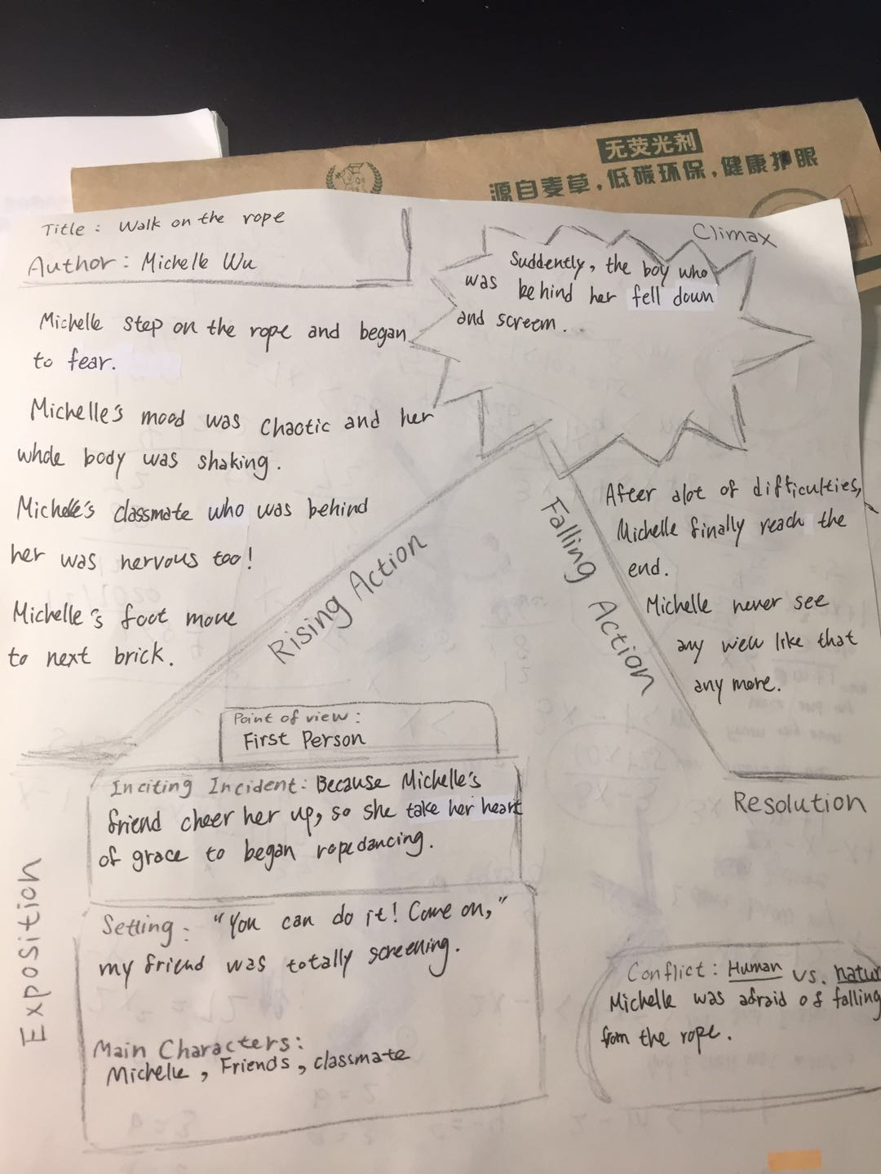

[Essay 4: Narrative Writing Exercise: Draft 1]

**The trouble of Liberation in the Epidemic**

That day was hot, everybody was sweating, and we have to show our ID to get in, but my classmate Isabella forgot to bring her ID. We were impatient of waiting.

Last month I went to South Luogu Lane with two other my best friends Grace, Candy and one of my classmate, Isabella. South Luogu Lane is a Chinese old lane, where sell different kind of tasty food, and funny things. We come out together is because my classmate was too boring at home so she want to come out have fun with us; but that day we have trouble to get in.

“Hi! I’m here! Come,” I shouted to her.

Isabella's home is very close to mine, so she invited me out to play, but I thought only two people are very boring, so I suggest that she invite my friends to come with us. We quickly make decision were we should go, and two other my friend were agree too. Because my friends had class in the morning until 12:00 that day, so we made an appointment at Candy house at 2 pm first, but they told me that their teacher had class early at 11:00 in the morning, so we quickly changed the time of that day and we changed the time to 12:30 in the afternoon. Isabella's home and my home are close to the same subway station. The subway station next to Candy home is the next stop of the subway station near us; so I made an agreement with Isabella that we should meet on the subway near my house at 12:15 that day. Because we change time quick that day, so we didn’t notice that Isabella didn’t check her phone, so she didn’t see that we change our time, so actually me and Isabella we didn’t have a deal, because she didn’t know about these things we had change.

At 12:00p.m., I quickly ran to the subway station, when I arrived it was exactly 12:15 p.m.; but she didn’t show up, so I called her, but she didn’t answer. I called her at least four time, but she didn’t answer. After twenty minutes, she called me,

“Michelle! I’m so sorry, I just saw you guys change the time, but I was eating lunch, please wait for me! I’ll be quickly,” she cried.

“Okay! I’ll wait for you! Please be quickly,” I quickly whisper to her.

After fifteen minuet she called me again,

“I’m here! Where are you,” she asked,

“Hi! I’m her! Come,” I shouted to her.

She finally came, but I wait her at least half hours, and Candy, Grace also waiting for her too.

We quickly arrived the subway station beside candy’s house and met them; and we also used one hour to get South Luogu Lane. After we arrived, we found out we need to have ID for get in. Me and my two friend all got ID, but Isabella didn’t, so she called her mom, asked her to send the picture of ID to her.

The day was hot, everybody was sweating, and we have to show our ID to get in, but my classmate Isabella forgot to bring her ID. We were impatient of waiting. Everybody is waiting for her. The cloud moved slowly, because there was no wind. Every people who sale fans came to bothering us. The cicadas on the trees are buzzing, pedlar were yelling. We all feel thirsty, but we still can’t get in.

Finally, her mom send her Isabella’s ID picture. We show our ID and favorably get in.

Word Count: 600

[Essay 4: Narrative Writing Exercise: Draft 2]

**The Trouble of Liberation in the Epidemic**

Last month I went to South Luogu Lane with two of my best friends, Grace and Candy, as well as one of my classmates, Isabella. South Luogu Lane is an old Chinese lane in Beijing, where you can buy all different kinds of tasty food and funny things. Isabella and I hung out together because she was too bored at home, so she wanted to go outside and have some fun. But that day we got into trouble.

Isabella's house is close to my house, so she invited me out to play, but I thought it was boring with just the two of us, so I suggested that she invite my friends to come with us. We quickly made decision were we should go, and my two other friends were agree too. My friends had class from the morning until noon that day, so first we made an appointment to meet at Candy’s house at 2 p.m. But they told me that their teacher had class early at 11 in the morning, so we quickly changed the time to 12:30 in the afternoon.

Isabella's home and my home are close to the same subway station. The subway station next to Candy’s home is the next stop of the subway line near us. So I made an agreement with Isabella that we should meet at the subway station near my house at 12:15 p.m. Because we changed time quickly that day, we didn’t notice that Isabella didn’t check her phone and didn’t see that we changed our meeting time. So actually Isabella and I we didn’t have a deal because she didn’t know about our changes.

At 12 p.m., I quickly ran to the subway station. When I arrived it was exactly 12:15 p.m., but Isabella didn’t show up. So I called her, but she didn’t answer. I called her at least four times, but she didn’t answer. After 20 minutes, she called me.

“Michelle,” she said. “I’m so sorry. I just saw you guys changed the time. But I was eating lunch. Please wait for me! I’ll be there quickly.”

“OK! I’ll wait for you!” I quickly whispered to her.” Please be fast!”

After 15 minutes she called me again.

“I’m here! Where are you?” she asked.

“Hi! I’m her! Come,” I shouted to her.

She finally came, but I had waited for her for at least half an hour. Candy and Grace were also waiting for her, too.

We quickly arrived at the subway station beside Candy’s house and met them. We then spent one hour to get South Luogu Lane. After we arrived, we found out we needed to have IDs to get in. My two friends and I all had our IDs, but Isabella didn’t have hers, so she called her mom and asked her to send her a picture of her ID.

The day was hot, everybody was sweating and we had to show our IDs to get in. But my classmate Isabella forgot to bring her ID. We were impatient of waiting. Everybody was waiting for her. The clouds moved slowly because there was no wind. Every person who sells fans came to bother us. The cicadas on the trees were buzzing, peddlers were yelling. We all feel thirsty, but we still couldn’t get in. Finally, her mom sent her a picture of her ID. We all showed our IDs and finally got inside.

There were so many tasty snacks there, like freshly grilled sauced squid and ice cream with cold cream flavor on freshly fried waffle rolls. The scent can be smelled from a distance. I've never eaten such delicious waffles and ice cream; I love how they put foods together and make a tasty snack. The ice cream there is really creamy and the freshly fried waffles are a pretty golden color. I was quite hungry, so every food looked attractive. We began shopping excitedly!

First, we ate grilled squid sprinkled with soy sauce. The smell of the squid totally smelled like home because Taiwan has the best seafood I have ever eaten! I love how they cooked the squid; it just made the squid’s color so tasty and smell so good!

Second, we ate ice cream in waffles! Ice cream is perfect for hot waffles. The ice cream tasted really creamy and also smelled like milk! The waffles were hot because they had just been fried! So this snack tasted both hot and cold!

The last snack we had ate was jasmine bay salty green tea. That is the best drink I had ever drank! There was caramel in the bottom of the drink, Japanese green tea in the middle of the bottle and fresh cream on the top of the drink! It sounds full of calories! I love South Luogu Lane – there is so much food!!!

After we finished our shopping, we were totally full! We finished our snacks and went home with grateful hearts. We had enjoyed our friendship and also had a great time!

Word Count: 835

[Story Arc: Essay 4: Narrative Writing Exercise]

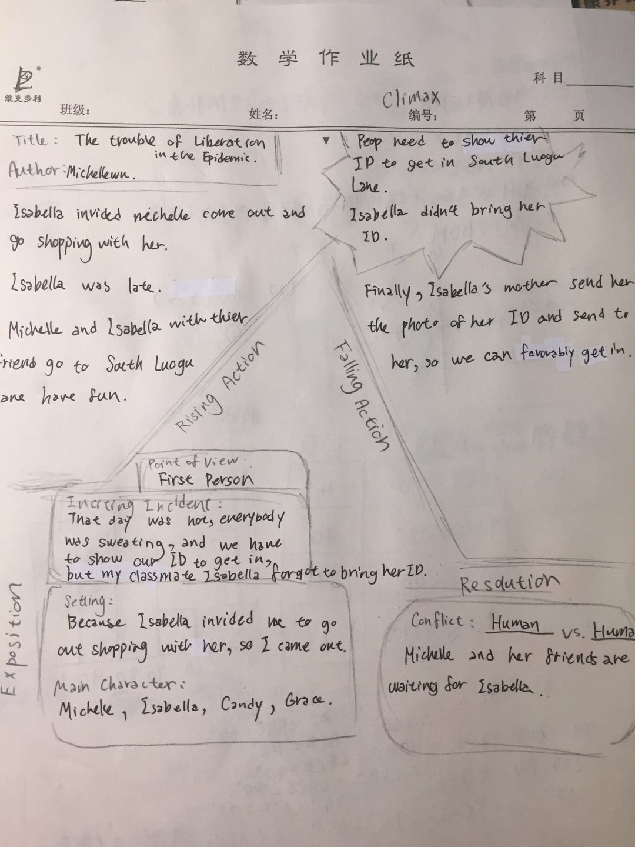

[Essay 5: Writing from the Point of View of a Fictional Character: Draft 1]

The truth that I left

When I was young, I lived in a poor village in 234 BC. Our village is cold all season, with no water; if we need water, we have to walk one kilometer to get to a well. One day in a peace normal morning, we heard the horseshoe from a distance. That day was the worst day of my life, blood splashes, women and children screaming. I run away and hide in a cave beside the village, I had stayed in there for three day with a bottle of water and a magical mirror that tells truth, and then I never see my parent since that day. I had lived in a forest for several years, I find a place that close to the river, so I don’t need to worry about no water. When I was 20 years old, I was founded by a King of England, he founded me and married him to be his wife. He had a beautiful daughter called snow white. She had beautiful white skin and skinny body with a lot of beautiful dresses. I like her, she was so kind and nice. But one day when I picked strawberries till night, there was many arrows struck me. I was afraid and worried, I ran away and quickly. I feel I might die at there, I was screaming and running. I have no time to breathe and cry. I was weary and my clothes was break in to piece. When I get back home, I took out my magical mirror,

“Who was trying to kill me? Why,” I asked tensely.

“It’s Snow white, she hate you that you replaced her mother, and she hate you because you are so beautiful,” the mirror answered with no feeling.

“I love her and she was so beautiful! Why she did this kind of thing,” I cried.

“She didn’t show her evil side to people,” mirror whisper,” She is behind your door!”

I don’t know that Snow white just stand behind the door before, she knew she was exposed. She quickly hired a hunter to pretend that I was going to kill her. She run in the woods and tempt seven dwarf to take in and bring up her. I was worried about her, she was so young she couldn’t just left. So I dress up like an old ugly woman that sell apples so she won’t know that I’m her stepmother, this thing is my problem, I didn’t knew that the apples are already has been moulded. She was sick and fainted, I worried about her, but I cannot be expose, so I ran away. Then, you know, prince came, and saved her, she found her love, but I was maltreat by her when she found out the “truth.” I dead, well it’s good to have this kind of life that have so much interesting character, right? Life like this, it happened all the time.

Word Count: 488

[Essay 5: Writing from the Point of View of a Fictional Character: Draft 2]

**The Truth That I Left**

When I was young, I lived in a poor village in 234 BC. Our village was cold all season, with no water. If we needed water, we had to walk one kilometer to get to a well. One day on a peaceful normal morning, we heard hoofbeats from a distance. That day was the worst day of my life, with splashes of blood, and women and children screaming. I ran away and hid in a cave beside the village, where I stayed for three days with a bottle of water and a magical mirror that tells truth. I never saw my parents again since that day.

I had lived in a forest for several years in a place that I had found close to the river, so I didn’t need to worry about not having water. When I was 20 years old, I was found by the King of England. He rescued me and took me to be his wife. He had a beautiful daughter called Snow White. She had beautiful white skin and a skinny body and lots of beautiful dresses. I liked her; she was so kind and nice to me.

One day in the middle of the night, I couldn’t sleep. I walked outside trying to find the path from the palace to the garden. I held my delicate antique handed lamp and airily walked on the flagstones. I heard owls hooting and the noise of wind slashing the old tung tree. I was humming along at a brisk pace and felt excited.

Suddenly, there was a groaning sound, but I didn’t notice it at first. I still walked through the byway in a cheerful mood. In a second, a sharp arrow flew at me. Luckily, I was not shot, but it scratched my cheek. I was scared and I knew that I couldn’t stay there anymore. I put out my lamp and quickly ran into the garden that I was going to. I crept quietly into the nearby bushes and held my breath for fear that I would fall to death. I heard footsteps near me. They were heavy and careful steps. I sat there for 10 minutes, until I heard the footsteps walking away. I carefully walked out. Suddenly…

“Stop!” a voice cried out in the dark. Even though I didn’t know who she was, I knew she was a girl and her bow and arrow were pointing at me.

“Who are you?” I said angrily to her. “Why are you trying to kill me.”

“That’s my question. Who are you?” “Why you’re trying to take away my mother’s place in my dad’s heart? Why are you tempting my father? You don’t belong here. You didn’t belong here!”

“Snow white? What are you doing here?” I cried with surprise. “Go back to your bedroom now!”

“What kind of power do you think you have that you can make commandments at me?” she replied, totally angry.

Then Snow White ran away, and I could not believe what I just saw and heard. I began thinking about what she had said. Had I hurt her spirit? Was I trying to replace her mother? But none of these accusations were true. She just made up excuses to make her feel better to hate me with no reason. I couldn’t believe that one day I would become the evil step mother.

Then, you know as the story goes, she ran into the forest, where dwarfs found her. Then the prince came and saved her, so she found her love. But I was maltreated by her when she told everyone the “truth” that she made for herself, “The evil witch poisoned her, and she ‘died.’ Then the prince found her.” So I died.

Well it’s good to have this kind of ‘life’ that has so many interesting characters, right? Life is like this; it happens all the time. Good luck doesn’t always follow innocent people. Some nice people die, some evil people live. That’s life.

Word Count: 667

[Story Arc: Essay 5: Writing from the Point of View of a Fictional Character]

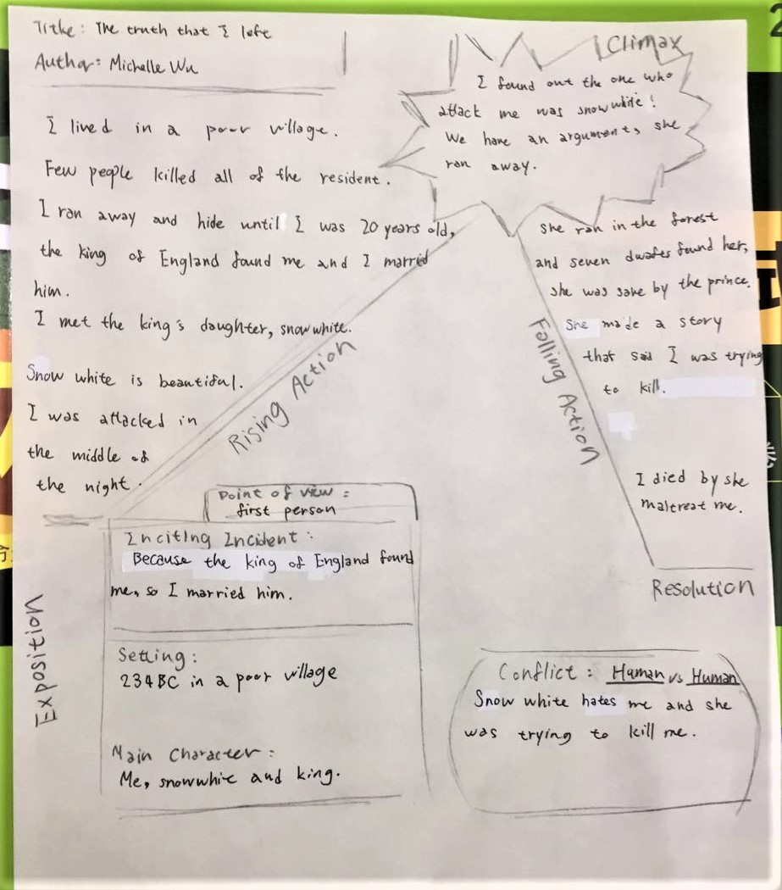

[Essay 6: Analyzing Literature: Noticing the Author’s Choices in “How the Leopard Got His Spots” by Rudyard Kipling: Draft 1]

Analysis of “How the Leopard got His Spots” by Rudyard Kipling

In the story of “How the Leopard got His spot”, the author, Rudyard Kipling made many choices, such as writing “weird” words, using third person, and using personification, to create a world that is talking about a Leopard who once is full of brown skin that is similar to the color of the stone and land so nobody see him when he is quiet. When Giraffe, Zebra, Eland, Koodo and Hartebeest are having rest or eating food, he and his friend, Ethiopian stand beside them and waiting for a good opportunity to catch them for breakfast. After a long time, Giraffe, Zebra and Eland had enough, they ran in to Great Forest and hide. Giraffe, Zebra, Koodo and Eland change their skin in to spot, stripe, and darker. After Leopard and Ethiopian found out their breakfast run away, they chase them in to the Great Forest, but they couldn’t found them because those animals have many different pattern on their skin same as different kind of plant in the forest. Ethiopian told Leopard he should have the pattern so they could hunt those animal faster. Then he paint Leopard spotty by his hand, and have happily ever after.

Firstly, Rudyard Kipling made the choice of writing” weird” words. His words is not actually weird, but he put them in to funny ways, like

” they were 'sclusively sandy-yellow-brownish all over; but the Leopard, he was the 'sclusivist sandiest-yellowish-brownest of them all a greyish-yellowish catty-shaped kind of beast.”- According to the article publish by China Translation & Publishing Corporation.

He used a lot of different kind of adjective on describing animals, and he used it vividly and amusingly. He had his own writing techniques and his own attitude towards writing. He didn’t write this story with curt boring words, he write this story audaciously, he didn’t think these word would make his story weird, he used it as innovative, and it did!

Then, he choose to use third person. It’s kind of familiar writing techniques, but it’s a good writing techniques on writing. Third person can make things that people want to narrate more clarity, because using “God’s view” can clearly write about what others’ thought and what everyone is doing even they weren’t together. Rudyard Kipling did a great job on this story, He made good use of the benefits of the third person. He let the reader clearly understand every movement of each animals’ action with no doubt.

Lastly, he choose to personification. I think this is the most important part of his story. He used the personification method well without doubt. He let this story became vivid and interesting, he also catch reader’s mind so reader will want to know what happen next. He skillfully used personification to make his story better understood and real. I think he made a good choice on this, because if he didn’t used personification, this story will definitely show up like BBC, not a children’s book.

Rudyard Kipling’s story is totally interesting and full of imaginations. The story of “How the Leopard got His Spot” have none unnecessary word. I think this story is very short and very clear, we could totally understand what the author is trying to tell us. Rudyard Kipling was a wonderful writer, his book is vivid, interesting and also conspicuous. I was totally in to this story.

Word Count: 560

[Essay 6: Analyzing Literature: Noticing the Author’s Choices in “How the Leopard Got His Spots” by Rudyard Kipling: Draft 2]

**Analysis of “How the Leopard got His Spots” by Rudyard Kipling**

In the story “How the Leopard got His Spots,” the author Rudyard Kipling made many choices, such as using “weird” description, writing in the third person narrator and using personification. Kipling uses these choices to create a world with a talking Leopard who once had brown skin that was similar to the color of stone and land, so nobody could see him when he was quiet. Whenever Giraffe, Zebra, Eland, Koodo and Hartebeest were having a rest or eating food, the Leopard and his friend, Ethiopian, would stand beside them waiting for an opportunity to catch them for breakfast.

After a long time, Giraffe, Zebra and Eland had had enough. So they ran into the Great Forest to hide. Giraffe, Zebra, Koodo and Eland changed their skin to spots and stripes and became darker. After Leopard and Ethiopian found out their breakfast had run away, they chased them into the Great Forest, but they couldn’t find them because those animals had many different patterns on their skin, the same as different kinds of plant in the forest. Ethiopian told Leopard he should also have some patterns so he could hunt those animals faster. Then he changed his skin to black and painted Leopard spotty with his dark hand, and they lived happily ever after.

Firstly, Kipling chose to use “weird” description. His words are not actually weird, but he put them in funny ways, such as, “They were ‘sclusively sandy-yellow-brownish all over; but the Leopard, he was the 'sclusivist sandiest-yellowish-brownest of them all, a greyish-yellowish catty-shaped kind of beast.” He used many different kinds of adjectives to describe the animals, which was vivid and amusing to read. He had his own writing techniques and his own attitude towards writing. He didn’t write this story with curt boring words. Instead, he wrote this story audaciously. He didn’t think these words would make his story weird. He used them innovatively, and it worked!

He also chose to use the third person narrator. It’s a familiar writing technique, but it’s a good one. Using the third person can make narrating a story more clear because from “God’s view” the author can clearly describe the characters’ thoughts and actions, even when they aren’t together. Rudyard Kipling did a great job writing this story. He made good use of the benefits of the third person. He let the reader clearly understand each animals’ every move without a doubt.

Lastly, he choose to use personification. I think this is the most important part of his story. He undoubtedly used the personification method well. This vivid and interesting story also catches the reader’s attention, so they will want to know what happens next. He skilfully used personification to make his story better understood and more lifelike. I think he made the correct choice because if he didn’t used personification, this story would definitely read like the BBC, not a children’s book.

In conclusion, Rudyard Kipling’s story, “How the Leopard Got His Spots,” is totally interesting and full of imagination. The story has no unnecessary words. I think it’s short and clear enough for me to understand what the author is trying to tell me. Kipling was a wonderful writer; his books are vivid and interesting, yet also conspicuous. I was totally into this story.

Word Count: 547

[Story Arc: Essay 6: Analyzing Literature: Noticing the Author’s Choices in “How the Leopard Got His Spots” by Rudyard Kipling]

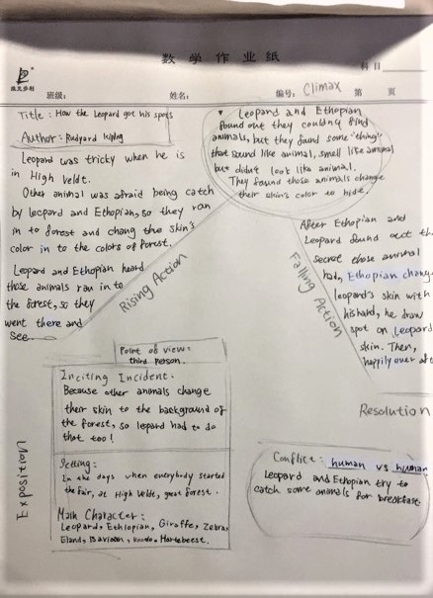

[Essay 7: Narrative Worksheet: Short Story: Draft 1]

**The End of the World**

I lived in 4020s, world only left with ruins; the city I lived in has no survivors but me, Diana and my friend, Leo. World War III began at 4017s, you can imagine who fast this world turning in to dust. People in this world didn’t really” die,” they are like “living corpse,” I called them “the dead.” They are just as same as you might know, bite everything live, and people will turning in to them. Me and Leo, had lived because we had protective clothing that came from my dad’s atelier, we need to wear it every day to protect us from the radiation. In World War III, every country began to shoot N-bomb, I think that is the cause of people turning in to “the dead.”

Leo and I travel to an island on the Atlantic by a map and few bottles of water on a boat, don’t asked me how I get there! When we got the island we found out there are two survivors who was call Andrew and Clara. I don’t know how can they escaped from the radiation by no protective clothing, then they told me the island didn’t get bombed, and it’s far away from USA. They came here to have a vacation, but after the day they arrived, world was destroyed, so they didn’t even know the World War III was end. Then Leo and I stayed there for weeks.

“Clara! Please come help me fix this boat! I couldn’t believe it was broken! Who did that?” I shouted.

“Diana, I think Leo just broke it, but I don’t know why. I think you should go and talked to him,” she whispered to me.

I quickly ran to the jacal beside the beach,

“Leo! Why did you brake the boat, we might use it,” I cried.

“Where could we go? We need woods to have fire, you know what I’m talking!”

“But what if anything goes wrong here? We need boats!”

Suddenly, land began to shake, I hold the wall tightly.

“Ahhhhhhhh! Help!”

A voice quickly came there, it’s Clara!

“Clara! Wait for me! I’m coming,” I screamed to her.

I quickly grabbed Leo’s hand and we support each other to keep each other from falling down.

“Clara! Grab my hand! Quickly,” I shouted.

Clara quickly jumped out of the broken boat and throw away the tools on her hand, she grabbed me!

“I knew it! My father once told me there are a big volcano in the Atlantic, and it is an active volcano. I think we are standing right up on it,” she cried.

“Clara! Leo! Diana! Where are you guys?”

We heard a voice was shouting, it must be Andrew!

“We’re here! Andrew! We’re here,” Clara cried.

“Let’s go! We need to get out of this island!” I was nervous.

We ran to the beach on other side of island.

“Look! There’s a boat! Let’s go! Quickly,” Leo whispered.

We pushed the boat in to the water, everybody got their own bottle of water and ship’s bread. When they all jump in to the water, the boat flow away.

“Diana! Quick, we’re going to flow away, jump on the boat! Quickly,” Clara shouted to me.

“I’m trying!” I almost cried,

“You guys are too far away from me! Oh no,”

Suddenly, a rope was thrown at me,

“Diana! Quickly grab this rope,” Andrew shouted,

“We have no more time! Quickly!”

I grabbed the rope and the boat stopped flowing, I quickly jumped on the boat and climb in.

“Thank you, Andrew!” I’m finally relieved.

“Bomb!”

A great sound came upon us with a great shock, is the volcano! It exploded! Magma quickly flowed out.

“We could be died now if we slow one second!” Clara laughed.

“Yeah! That was really closed!” Leo and I laughed too.

“Well, thanks God!” Andrew forced smile, he looks exhausting.

We flowed on the ocean for hours, but luckily, the rescue personnel came to search for survivors, and they saw us. That is totally lucky. We being taken to a survivor camp, most of the survivors are same age as us, sixteen to thirteen. Well, the story will end here, I got to wake up five a.m. tomorrow. Goodnight.

Word Count: 730

[Essay 7: Narrative Worksheet: Short Story: Draft 2]

**The End of the World, Part 1**

I lived in the 4020s, when the world was only left in ruins. The city I lived in had no survivors but me, Diana, and my friend Leo. World War III began at 4017s and you can imagine how fast this world turned into dust.

People in this world didn’t really “die,” they were more like “living corpses.” I called them “the dead.” They were just as same as you might imagine, biting every living thing, and people you know turned into them. Leo and I had survived because we wore protective clothing that came from my dad’s atelier. We needed to wear it every day to protect us from the radiation. In World War III, every country began to shoot the N-bomb. I think that is what caused people to turn into “the dead.”

Leo and I traveled to an island in the Atlantic using just a map and a boat with a few bottles of water – don’t ask me how we got there! When we arrived at the island we found out there were two other survivors named Andrew and Clara. I don’t know how they were able to escape from the radiation without wearing protective clothing. Then they told me the island didn’t get bombed and it was far enough away from the USA. They had come here to have a vacation, but the day after they arrived the world was destroyed, so they didn’t even know that World War III had ended. Then Leo and I stayed there for weeks.

“Clara! Please come help me fix this boat!” I shouted. “I can’t believe it’s broken! Who did that?”

“Diana, I think Leo just broke it, but I don’t know why,” she whispered to me. “I think you should go and talk to him.”

I quickly ran to that jacal beside the beach.

“Leo! Why did you break the boat?” I cried. “We might have used it!”

“Where could we go?” he asked. “We need woods to make fire. You know what I’m talking about!”

“But what if anything goes wrong here?” I said. “We need boats!”

Suddenly, the land began to shake. ~~I held the side of the wall tightly.~~

“Ahhhhhhhh! Help!” we both cried.

Then we heard a voice shouting to us quickly. It was Clara!

“Clara! Wait for me! I’m coming,” I screamed to her.

I quickly grabbed Leo’s hand and we supported each other to keep from falling down.

“Clara! Grab my hand! Quickly,” I shouted.

Clara quickly jumped out of the broken boat and threw away the tools in her hand. She grabbed me!

“I knew it!” she cried. “My father once told me there is a big volcano in the Atlantic, and that it’s an active volcano. I think we are standing right up on it!”

“Clara! Leo! Diana! Where are you guys?”

We heard a voice shouting. It must be Andrew!

“We’re here! Andrew! We’re here,” Clara cried.

“Let’s go! We need to get off of this island!” I said nervously.

We ran to the beach on other side of island.

“Look! There’s a boat!” Leo whispered. “Let’s go! Quickly!”

We pushed the boat into the water. Everybody had their own bottle of water and ship bread. When they all jumped into the water, the boat floated away.

“Diana! Quick!” Clara shouted to me. “We’re going to float away. Jump on the boat! Quickly!”

“I’m trying!” I almost cried. “You guys are too far away from me! Oh no!”

Suddenly, a rope was thrown to me.

“Diana! Grab this rope,” Andrew shouted. “We have no more time! Quickly!”

I grabbed the rope and the boat stopped floating away. I quickly pulled myself toward the boat and climbed in.

“Thank you, Andrew!” I said, finally relieved.

*Boom!*

A great sound came upon us with a great shock – it was a volcano! It exploded! Lava quickly flowed out.

“We could be died now if we were one second slower!” Clara declared, laughing.

“Yeah! That was really closed!” Leo and I said, laughing, too.

“Well, thank God!” Andrew said, forcing a smile.

He looked exhausted.

We floated on the ocean for hours, until some rescue personnel came searching for survivors and luckily they saw us. That was totally lucky. We were taken to a survivor camp, where most of the survivors were the same age as us, ages 16 to 13.

Well, the story will end here. I have to wake up five a.m. tomorrow. Goodnight.

To be continued…

Word Count: 746

[Essay 8: Letter to Captain: Draft 1]

**Write a Letter to Captain**

I had learn a lot in this course. This class let me remember a lot of rules in writing I had learn before, and it let me understood many important rules we should follow in writing.

The first thing I had learn some rules about writing research paper, like using quotation marks and write down the website about where you get that information. The second thing I also had learn is how to draw an arc before writing a narrative, it could help us to write the story in order. The last thing I had learn is using different kind of adjective, adverb and verb, like using enormous to replace big, using adorable to replace cute. This class really help me doing on writing essay.

I like about this course is because I actually really learned in this class. I also feel excited to be in this class because both teacher and classmates all work hard and they all really in to this class. This class has a good atmosphere and good attitude on everybody. Miss Shannon and Mr. J will answer my question all the time even in the day that we don’t have class, and they really have a lot of patient on me. I’m thankful to these two teacher.

I think maybe in next time teacher can give us feedback quicker, so we could write our draft2 immediately and it doesn't drag the draft2 to the end of the course. I hope teacher could give us the draft2 on time so we won’t have too much works to do at the end of the class. I think I think next time I would try my best to do all the homework faster and clearer. I think I also can be more patient next time. I would still try my best to work on homework and classes.

Word Count: 309

[Essay 8: Letter to Captain: Draft 2]

**Letter to Captain**

Dear Captain,

I have learned a lot in this course. This course helped me remember a lot of rules in writing that I had learned before, and it helped me understand many other important rules we should follow.

The first thing I have learned are some rules about writing research papers, like using quotation marks and writing down the website where I got my information. The second thing I have also learned is how to draw a story arc before writing a narrative. It can help me to write the events of a story in order. The last thing I have learned is to use different kinds of descriptive adjectives, adverbs and verbs, such as using “enormous” to replace “big” and using “adorable” to replace “cute.” This class really helped me improve my essay writing.

What I like about this course is that I actually really learned something in class. I also felt excited to be in this class because both teachers and classmates all worked hard and they were all really in to this class. This class had a good atmosphere and everybody had a good attitude. Miss Shannon and Mr. J would answer my questions all the time, even on the days that we didn’t have class, and they really had a lot of patience with me. I’m thankful for these two teachers.

Next time I think maybe you and Miss Shannon can give us feedback more quickly, so we could write our draft 2 immediately and it wouldn’t drag the draft 2 to the end of the course. I also hope we won’t have many technical problems, so we can have our class immediately. I think next time I would try my best to do all the homework faster and more clearly. I think I can also be more patient next time. I would still try my best to work on homework and participate in class. Thank you, Captain and Miss Shannon!

Your student,

Michelle Wu

2020/08/16

Word Count: 322

**II**

**Journal Entries**

[Journal 1: Do you enjoy writing? Why or why not?: Draft 1]

**Do you enjoy writing? Why or why not?**

I do enjoy writing, but it depends on different kind of time. Sometimes when I been through something fun and excited, I want to depict it down in my writing. Sometimes when I was angry to somebody or something I would be willing to write it down to express my indignation. To tell you the truth, if I could choose to do anything I wanted to do, writing wouldn't come first. But generally speaking, I do love writing, and I love how people express their feeling in their writing too.

[Journal 1: Do you enjoy writing? Why or why not?: Draft 2]

**Do you enjoy writing? Why or why not?**

I do enjoy writing, but it depends on the situation. Sometimes when I have experienced something fun and excited, I want to jot it down in my journal. Sometimes when I am angry at somebody or something I would be willing to write it down to express my indignation. To tell you the truth, if I could choose to do anything I want to do, writing wouldn't come first. But generally speaking, I do love writing, and I love how people express their feelings in their writing, too.

[Journal 2: What is the one thing that you want to change about yourself?: Draft 1]

**What is one thing you would like to change about yourself? Why?**

I would love to get rid of the fact that I’m afraid of having lecture in the public. I’m not able both having eye contact to the audience and having loud voice. I always already began sweating before I even step on the stage; But every time when I saw the audience’s face, I will be so nervous. Even thought that I already practice so many time, I still couldn’t get rid of the psychology of fear. I have this trouble for a long time, and I think I could be braver and I will be braver to defeat this kind of psychology.

[Journal 2: What is the one thing that you want to change about yourself?: Draft 2]

**What is one thing you would like to change about yourself? Why?**

I would love to overcome my fear of public speaking. I am unable to maintain eye contact with the audience while speaking with a loud voice. I always begin sweating before I even step on the stage, and every time I see the audience’s faces, I become so nervous. Even though I would have already practiced my speech many times, I am still unable to overcome my psychological fear. I have had this problem for a long time, and I wish I could be brave enough to defeat this kind of mental block.

[Journal 3: What unexpected thing happened to you recently? Why?: Draft 1]

**Journal Prompt 3: What unexpected thing happened to you recently? Why?**

Everything has come so fast this year, and new events already have begun before I can react. Everyday sunset fade away, but none of these things end. I could say that God is warning us, something is coming, and we could not stop it; But life keep moving on, time would not stop because of these trouble. It is not the world that makes you too disappointed, is you have too much expectation to the world. The thing that unexpectly just happen to me or anybody was the coronavirus.

Coronavirus cause a lot of events happened, most of it was negative. I’m stuck at home for month, and I could not go out. The positive thing that happened was that I have more time together with my family; and second is that I have more time to study myself. The negative things happen was that I could not see my friend and my teacher, I could not breath the fresh air and I got fat. If I compare with the time I used to go to school every day, I will still want to go to school. The difference between homeschool and school is that teacher will point out the key point of what you need to learn if you were in daily school; in homeschool you need to point the key point out yourself, and you need to figure out the thing that you don’t understand yourself.

I think if anything like this epidemic happen again I will still follow the instructions of the Government. Stay at home as much as I can, go out and wear a mask and keep social distance. I think I will do better on my homeschool study, like find the key point quickly and work on the thing I don’t really understand. I think I will do better on cleaning, because I didn’t really wash my hand every day I come home, so that’s a little dangerous; and I didn’t wear mask every second, sometimes I take off because it was really hot.

I think China did a good work to fix the problem, and I think they should to help other countries’ epidemic; because if only few countries have control the virus will not working, only somebody find out and make out the cure successfully, the virus will gone. I hope this epidemic could end as soon as it could be.

[Journal 3: What unexpected thing happened to you recently? Why?: Draft 2]

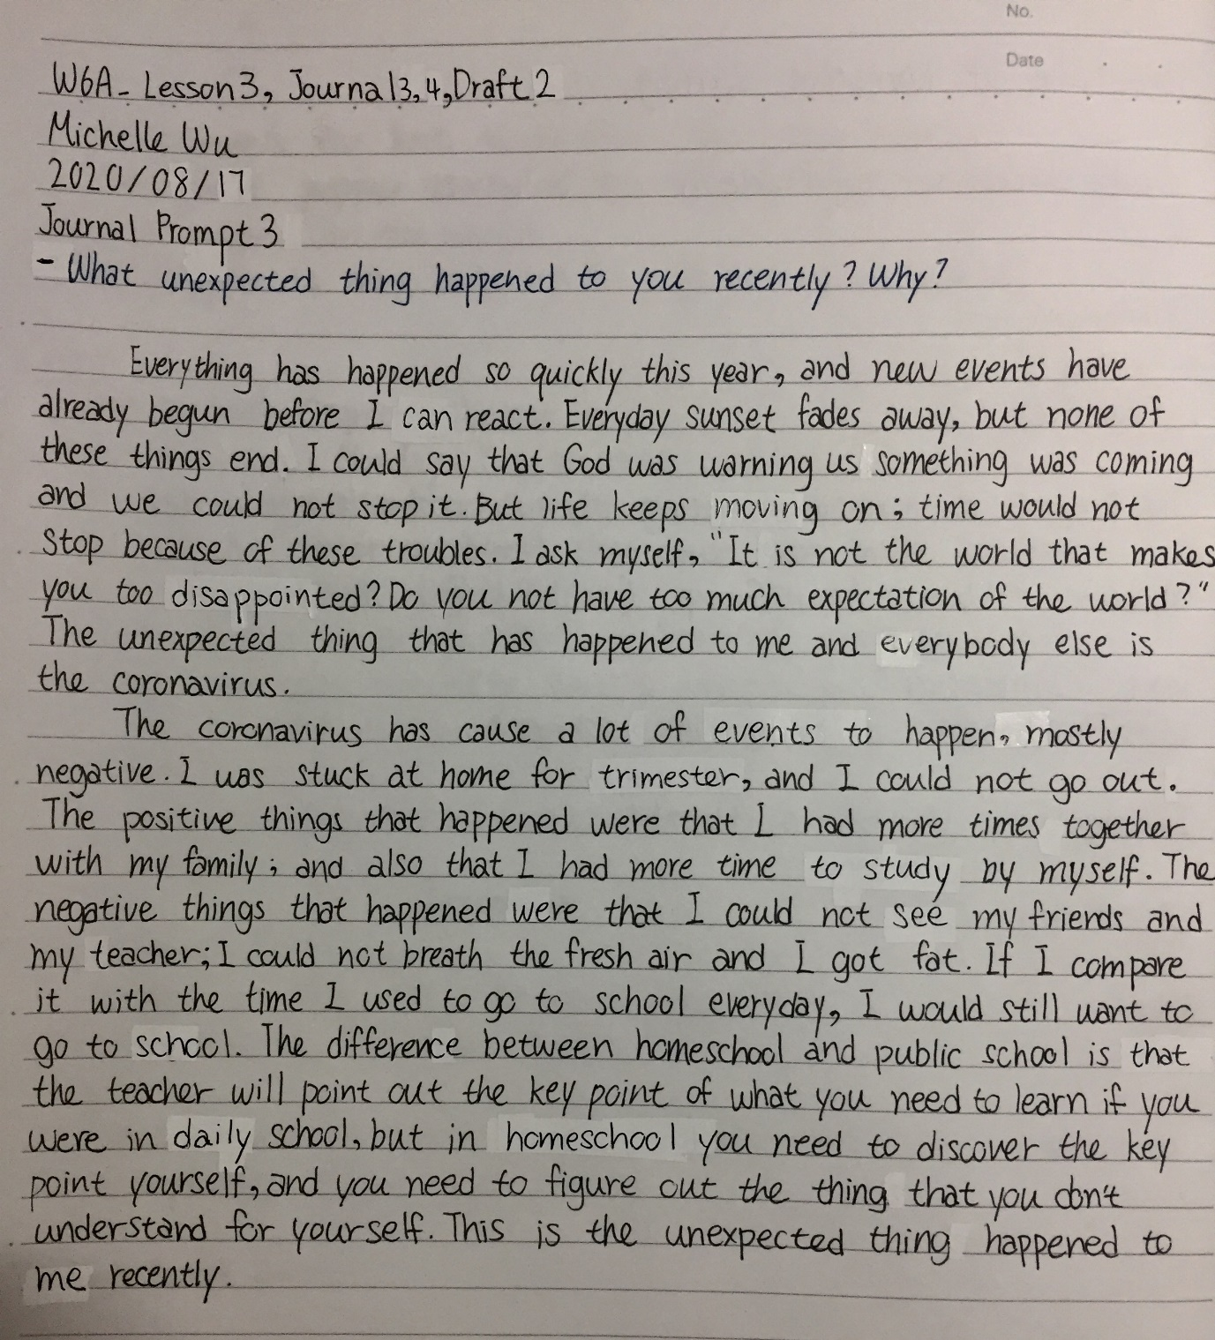

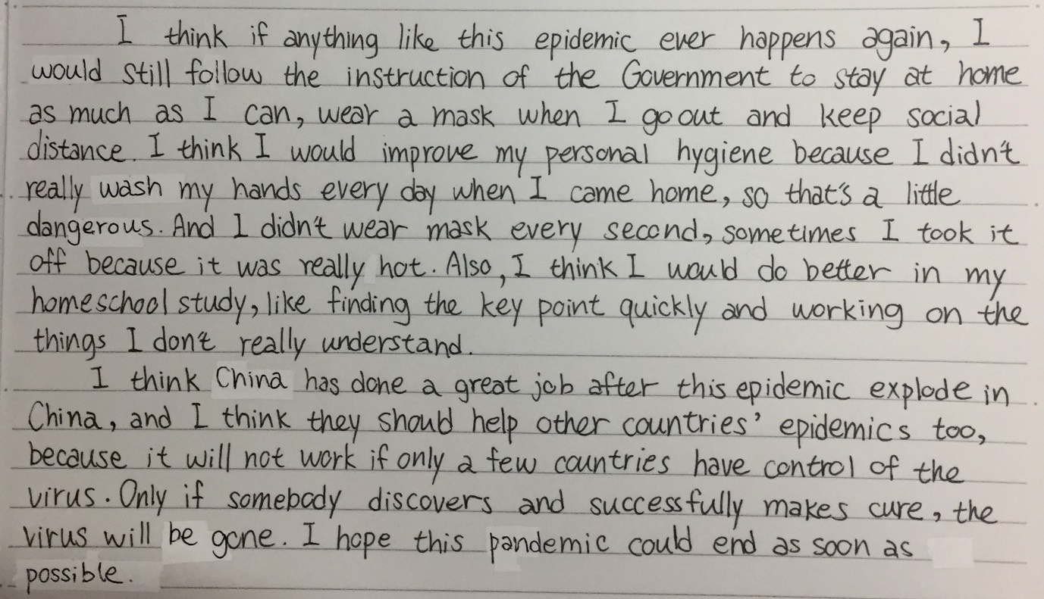

[Journal 4: What are three reasons why the global pandemic is good?: Draft 1]

**Journal Prompt 4: What are three reasons why the global pandemic is good?**

Covid-19 are the global epidemics we having now. Many people lost their jobs, families, friends, lover cause of this global pandemic. Some people even went to rob stores because they don’t have money for life. Every students were staying at home having online classes, and no one find out the cure or something could end this mess. Everyone thinks the epidemic is only a negative things 0for us, but it's also have some positive things to us, like reorganization, understand clearly, and accompany.

First, Reorganization; People are beginning to discover what their national leader’s personality is. Take the USA, for example. President Trump didn’t really help his people to fix what’s happening. For another example, mayor of New York City, he did a great job after the epidemic explode in New York City. Well, people can always do things to their advantage because God give us chance, but sometimes there are conflicts of interest, it depends on which way you want to choose. Who's going to help people stay away from viruses and germs?

Second, understand clearly; People are beginning to realize that global warming is progressing rapidly, it’s not just a fairy tale. People began to attach importance to environmental protection. Now China have mention that since the end of 2020 Non-degradable disposable plastic straws are banned in the catering industry nationwide. People start to find out that we have to take action to protect our earth. Because of the virus appear let us realize we could just consume the resource on the earth, we need to take action.

Last, Accompany; I’m sure that many people didn’t have the time to accompany their families. People need to work every day, and children need to go to school every day; but because of the virus, we came back to accompany our grandmother, grandfather, children, parents. Virus bring back us together when everybody all selfish and only care about themselves. Many people were closer with their family. The virus has brought us back together when everybody seem each other as strangers. Because of the virus appear let us understand we need to have more time with our family.

Nothing is only bad, everything have positive and negative, don’t forget each side. Just like rose, you can’t just see the flower and forgot the thorn; either way, you can’t just look at thorn and forgot the beauty of the flower. God always give us best, even we thought this was awful, but actually God will give us a more than what we had asked. Covid-19 let people suffering, but it also let us understand what the most important thing is now.

[Journal 4: What are three reasons why the global pandemic is good?: Draft 2]

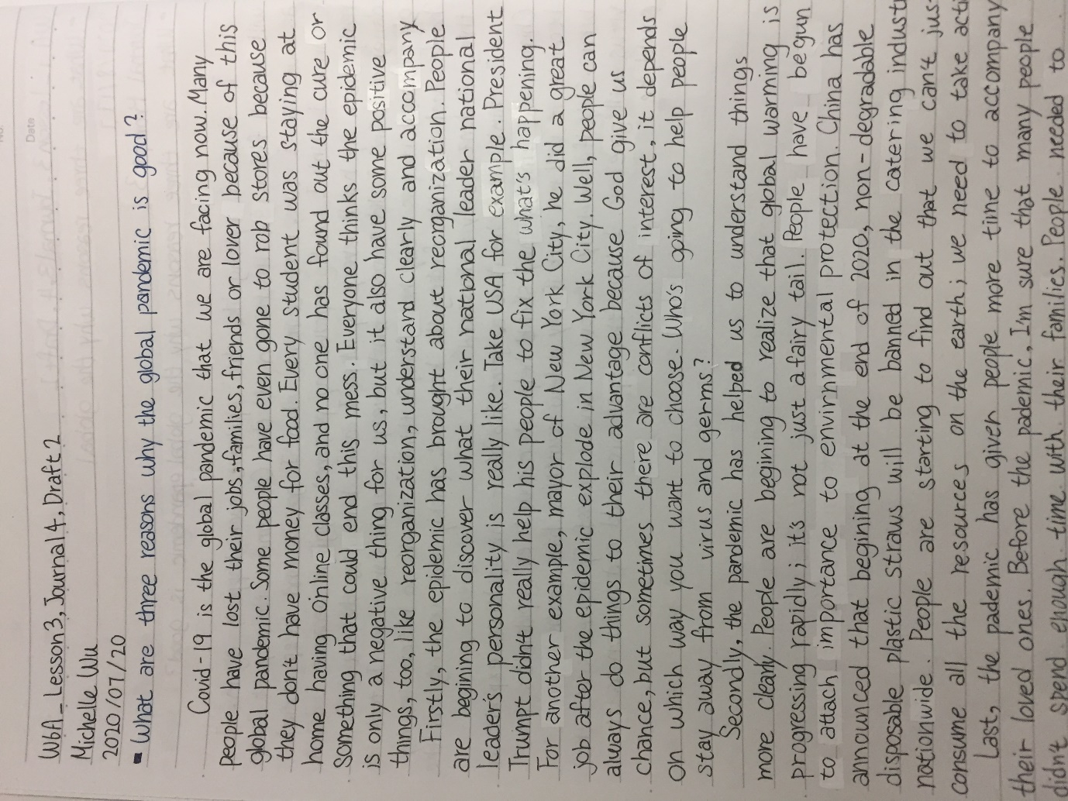

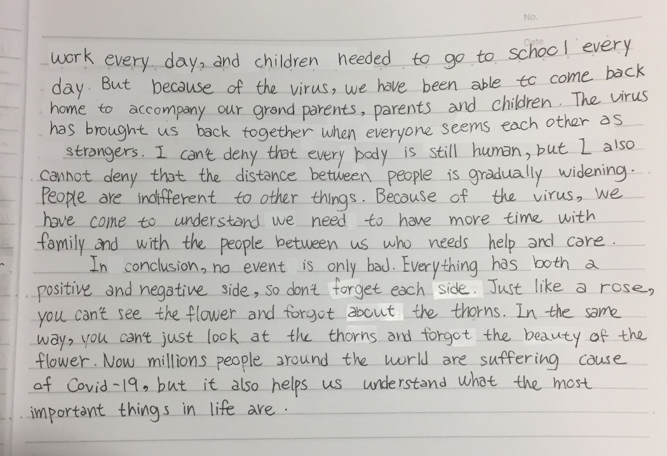

[Journal 5: Write a 200-300 word summary of the article. Use three direct quotes.: Draft 1]

**Journal Prompt 5: Summary of “A lovely bunch of coconuts and all that”**

Summary of “A lovely bunch of coconuts and all that”

This report is about how precious and nutritious coconut is, and it talked about some short story that have to do with coconut. Frist, the report began with an event of an allegations of misuse of Thai monkeys to coconut and other harvest fruits. The people who did this things profess that he didn’t “abuse” those monkey. He said that the monkey was hurt is because he doesn’t familiar to training monkey. He start to talk about the experience of visited to the South, and he said the coconut was very hard to took, only the monkey can climb up the tree and get it. The second story was talked about a person’s recall, when he was young, coconut was the same as banana, full of the fairly exacted; and people love coconut even made a lovely song for it. He love knocked coconut off its perch hardly, but he didn’t realize there are so much coconut had been dialed down when he knocked coconut off its perch. The third story is talking about people used to crazy about the coconut song, and decided to play it every time when Cambridge United Football Club win. The fourth story is talking about a one crew have a lot of coconut on the boat when they have a disaster on the boat and lose connection to the lifeboat, and they survived because coconut is rich in nutrients and water. The last story is talking about how high the coconut was in Thailand and PC times. This article tells us more about coconut, and let us understand more about how precious coconut is.

[Journal 5: Write a 200-300 word summary of the article. Use three direct quotes.: Draft 2]

**Journal Prompt 5: Summary of “A lovely bunch of coconuts and all that”**

**Summary of “A lovely bunch of coconuts and all that”**

This article is about how precious and nutritious the coconut is, and it told a short story that has to do with coconuts.

Firstly, the article began with the news about allegations of misuse of Thai monkeys to harvest coconuts and other fruits. The people who do these things profess that they don’t “abuse” those monkeys. One coconut farmer said that some people think the monkeys are getting hurt because they aren’t familiar with training monkeys. He talked about the experience of visiting the South, and he said coconuts are very difficult for humans to pick; only the monkeys can climb up the trees and get them.

Then the writer told a story about when he was young and the coconut was the same as the banana, a fairly exotic fruit in the UK. People loved coconuts so much that they even made a lovely song about them. He love to knocked coconuts off their trees ~~hardly~~, but he didn’t realize there were so many coconuts that had been dialled down when he knocked a coconut off its perch.

The third story talked about how people used to crazy about the coconut song, and decided to play it every time Cambridge United Football Club won a match.

The fourth story talked about a crew that had a lot of coconuts on their ship when they had a disaster on the ship and lost connection to the lifeboat. But they survived because coconuts are rich in nutrients and water.

The last story talked about how high the coconut was in Thailand and PC times. This article tells us more about the coconut, and helps us understand how precious it is.

[Journal 6: Write your opinion of the situation. Do you agree or disagree? Why?: Draft 1]

**Journal Prompt 6: Opinion of the article “A lovely bunch of coconuts and all that”**

Opinion to the report of “A lovely bunch of coconuts and all that”

I think the report is good, but I couldn’t really catch the point of it; I didn’t understand what actually does the author trying to tell us; but I think the point of the report is telling us how precious and how nutritious coconut is. I agree to the author, coconut is valuable, because it’s hard to get and nutritious, but I never really knew how to open it without let the water flow out. I think coconut is a good fruit whatever it’s hot or cold. I think the author of this article cited a lot of short stories was trying to let us discover all the things about coconut our self in these stories. Although I don't understand the structure of this article very well, I find the little story in this article interesting

[Journal 6: Write your opinion of the situation. Do you agree or disagree? Why?: Draft 2]

**Journal Prompt 6: Opinion of the article “A lovely bunch of coconuts and all that”**

**Opinion of the article “A lovely bunch of coconuts and all that”**

I think the article is well written, but I couldn’t really catch the point of it; I didn’t understand what the author was actually trying to tell us. But I think the point of the article is to tell us how precious and how nutritious coconuts are.

I agree with the author that coconuts are valuable because they’re hard to get and nutritious, but I never really knew how to open them without letting the water flow out. I think coconuts are a tasty fruit whether they’re served hot or cold. I think the reason why the author of this article told a lot of short stories is because he is trying to help us discover all the interesting things about coconuts for ourselves. Although I don't understand the structure of this article very well, I find the little stories are interesting.

[Journal 7: What character traits are most important to you? Why?: Draft 1]

**Journal Prompt 7: What character traits are most important to you? Why?**

The most important character traits is I can everybody’s personality quickly even they didn’t acted it out. The first reason of I think this is my most important personality is I don’t usually provoke others, because I always carefully avoiding anger of others, so I have good relationship with many people. The second reason is that I always know what other people like and don't like, so that I know what to do to others to achieve what purpose, but I never use unscrupulous divisive tactics or to reach my destination with an unfaithful friendship, I always have faithful friendship. The last reason is I know exactly how to improve my relationship with other people and improve it in a way that is acceptable to both sides; I also know how to destroy the relationship with others, but I never did that. I think this character traits is very important to me, so I can easily have good relationship; and of course I have this character trait is also because I have experienced a lot of things and have seen a lot of things happen and end to know how to improve my emotional intellig

[Journal 7: What character traits are most important to you? Why?: Draft 2]

**Journal Prompt 7: What character traits are most important to you? Why?**

As for me, my most important character trait is to ability to sense anyone’s personality quickly even before they have expressed themselves.

The first reason why I think this is my most important characteristic is because I usually don’t provoke others and carefully avoid angering others. So I have a good relationship with many people.

The second reason is that I usually know what other people like and don't like, so that I know how to treat others in order to achieve a particular purpose. But I never use unscrupulous or divisive tactics to achieve my goal as an unfaithful friend. On the contrary, I am always a faithful friend.

The last reason is I know exactly how to improve my relationship with other people and improve it in a way that is acceptable to both me and the other person; I also know how to destroy the relationship with others, but I’ve never done that.

In a word, I think this character trait is very important because it always me to easily have good relationships. Of course, I have this developed this character trait because I have experienced and seen a lot of things happen, so I know how to improve my emotional intelligence.

[Journal 8: Why do some people struggle to do the right thing?: Draft 1]

**Journal Prompt 8: Why do some people struggle to do the right thing?**

So many people struggle to do the right thing, and why? I think one of the reason is most of the people were not “struggle” to do the right thing, is something might force them not letting them to do the right thing, like, bully. Many school have bully between the students, even teacher. Why did no one come forward to help those who were excluded, were bullied? Because people afraid to be bully too, they don’t want to stop other from bully others, they afraid they will be bully by them too. Another reason is some people are selfish, they only do something that will help them; they think do the right thing wouldn’t help them to get anything. Well, some people struggle to do the right thing is because they think do right thing is not fun, they like to see people suffered, or sad, but I don't think there's a lot of people do this kind of thing. There still a lot of people on the world are doing right thing every day, so let’s not just look at negative side.

[Journal 8: Why do some people struggle to do the right thing?: Draft 2]

**Journal Prompt 8: Why do some people struggle to do the right thing?**

So many people struggle to do the right thing. Why?

I think one reason is because some people do not really “struggle” to do the right thing. In fact, some outside factor like a bully might prevent them from doing what is right. Many schools have bullies among the students, even some teachers. Why does no one come forward to help those who are excluded or bullied? Because the other people are afraid to be bullied, too. They don’t want to stop the bully because they are afraid they might also be bullied by them.

Another reason is because some people are selfish; they only do something that will help themselves. They might think that doing the right thing wouldn’t help them to get anything. There’s nothing in it for them.

Well, other people struggle to do the right thing because they might think that doing the right thing is not fun. Perhaps they actually like to see other people suffer or be sad. Fortunately, I don't think there are a lot of people who act this way.

In the end, I believe there are still a lot of people in the world who are doing righteous deeds every day. So be positive and don’t just look at the negative side of life.

[Journal 9: What does it mean to have integrity?: Draft 1]

**Journal Prompt 9: What does it mean to have integrity?**

I think there is nothing on the world is perfect. If people called somebody is integrity, that’s mean he/she is more integrity than normal people, that doesn’t mean he is totally integrity on anything. People always think they love integrity people, but the truth is not what they think; because integrity people seek for righteous, but sometime right thing doesn’t always have right ending. Like, some single mom have no more money to raise her own kids, but she still want to keep her own children beside her; but the most of the time that court will take the children away from their mother, and put them in the orphanage. It’s the right thing, but it’s not humanization. The meaning of have integrity is to have the quality of honest, and full of righteous. –

[Journal 9: What does it mean to have integrity?: Draft 2]

**Journal Prompt 9: What does it mean to have integrity?**

I think nothing in the world is perfect. If people say somebody has integrity, that probably means he/she has more integrity than normal people, but that doesn’t mean he/she has perfect integrity in anything. People always think they love people with integrity, but the truth is not what they think. Because people with integrity seek for righteous, but sometimes the right thing doesn’t always have a right ending. Take for example a single mom who doesn’t have enough money to raise her own kids, but still wants to keep them beside her. Most of the time, the court would take the children away from their mother and put them in the orphanage. According to the law, it’s the ‘right’ thing to do, but it’s not humane. The meaning of integrity is to have the quality of being honest and full of righteous.

[Journal 10: What is the hardest lesson you’ve ever had to learn? Why?: Draft 1]

**Journal Prompt 10: What is the hardest lesson you’ve ever had to learn?**

I think the hardest lesson I’ve ever had to learn is get rid of everything you are addictive. It’s hard, and people could get rid of these thing by them self. Like some people are addictive to movies, they watch movie every day, every minuet, every second, at breakfast, at work, at lunch, at dinner, at shower, before bed. Some people are addictive on work, work every day, even break, even family meeting, even with friends, even went they already tired. Bible said everything that you are addictive is awful. You can have you favorite thing to do, but if it already became addictive, it’s bad.

[Journal 10: What is the hardest lesson you’ve ever had to learn? Why?: Draft 2]

**Journal Prompt 10: What is the hardest lesson you’ve ever had to learn?**

I think the hardest lesson I’ve ever had to learn is getting rid of everything I am addicted to. It’s hard for people to get rid of these things by themselves. For example, some people are addictive to movies. They watch movies every day, every minute, every second; at breakfast, at work, at lunch, at dinner, in the shower and before bed. Other people are addicted to work. They work every day, during even break; even during family meetings, even when hanging out with friends, even went they are already tired. The Bible says that everything you are addicted to is awful. You can have your favorite thing to do, but if it has already became an addiction, then it’s bad for you.

[Journal 11: What is your favorite way to show your individuality? Why? Draft 1]

**Journal Prompt 11: What is your favorite way to show your individuality?**

I’m kind of listener, I always listen to everybody, some people complain about their parent to me, and some people narrate about people around them to me. Some people asked me about what choice should they make. People trust me and told me their troubles, I listen and give them my advice. I think I’m a good listener to people around me; but my advice is always rational, so I won’t stand at your side is because you are my friend, but usually I told people politely, and most of the time I still stand at my friend’s side. So I could said that I’m a good listener, because I could help my friends and give what they need.

[Journal 11: What is your favorite way to show your individuality? Why?: Draft 2]

**Journal Prompt 11: What is your favorite way to show your individuality?**

I’m more of a listener; I always listen to everybody. Some friends complain about their parents to me and other friends gossip about people around them. Some friends have asked me about what choices they should make. When people trust me enough to tell me their troubles, I listen and give them my advice. I think I’m a good listener to those around me. But my advice is always rational, so I won’t stand on your side just because you are my friend. Usually I tell people the truth politely, and most of the time I still stand on my friend’s side. So I could say that I’m a good listener because I can help my friends and give them the true advice they need, not just what they want to hear.

[Journal 12: If you could take home any animal from the zoo as a pet, which would you choose?: Draft 1]

**Journal Prompt 12: If you could take home any animal from the zoo as a pet, which would you choose – and why?**

I will take raccoon back home, because they are cute!!! First time I saw raccoon is last year Christmas in Australia, my family travel to Australia to visited my sister who was studied in Sydney. I saw three raccoon in the zoo, and they are so cute!!! I couldn’t put my sight away from them. I know that raccoon is very smart and very tricky, it has flexible body and it can walk with two feet, they love finding food in garbage; but they still so cute! They love” washing food” to find the shape of food. They love water too, they love taking bath and swimming. If I could take home any animal from the zoo, I will take raccoon home, definitely.

[Journal 12: If you could take home any animal from the zoo as a pet, which would you choose?: Draft 2]

**Journal Prompt 12: If you could take home any animal from the zoo as a pet, which would you choose – and why?**

I would take a raccoon back home because they are cute!!!

The first time I saw a raccoon was last year Christmas in Australia, when my family travelled to Australia to visit my sister who was studying in Sydney. I saw three raccoons in the zoo and they were so cute!!! I couldn’t take my eyes off them.

I know that raccoons are very smart and tricky. They have flexible bodies and can walk with two feet. They love finding food in the garbage, but they are still so cute! They love “washing food” to find its shape. They love water, too; they love taking baths and swimming.

If I could take home any animal from the zoo, I would definitely take home a raccoon.

[Journal 13: What is your favorite way to show your individuality?: Draft 1]

**Journal Prompt 13: What is your favorite wat to show your individuality?**

I think the most important part of being a good friend is telling truth. Many people might think it’s not a good action to tell their friends what they do is right or wrong, but I say that only there is a people who really listen to what your suggest is the friend that you should make. When we are talking to our friends, we shouldn’t talking like making commandment, we should make sure we are really saying these things just for their goods. I think it’s really important to be honest and make friend sincere, others definitely know who are really be sincere and honest to them.

[Journal 13: What is your favorite way to show your individuality?: Draft 2]

**Journal Prompt 13: What is your favorite wat to show your individuality?**

I think the most important part of being a good friend is telling the truth.

Many people might think it’s not a good idea to tell their friends what they do is right or wrong. But I say that only the person who really listens to your suggestions is the friend that you should make.

When we are talking to our friends, we shouldn’t speak like we’re making commandments. Rather, we should make sure we are really saying these things just for their own good.

I think it’s really important to be honest and make friends sincerely. People definitely know who are really being sincere and honest to them.

[Journal 14: Who is your hero? What inspires you about this person?: Draft 1]

**Journal Prompt 14: Who is your hero? What inspires you about this person?**

There are many people can be my hero, but I will only tell one. I’m a Christian, I know God is my hero because when I get to a lot of sadness and loneliness, he was always there be with me. He didn’t talk to me, but I know he used things to let me know what he is trying to tell me. He give me a lot of things even I never asked to him or anybody. He always be with me whatever I been through. I know he love me isn’t because what talent I have, he love me because he made me, so I know he is my hero.

[Journal 14: Who is your hero? What inspires you about this person?: Draft 2]

**Journal Prompt 14: Who is your hero? What inspires you about this person?**

There are many people could be my hero, but I will only mention one.

I’m a Christian. So I know Jesus is my hero because whenever I encounter a lot of sadness and loneliness, he is always there with me.

Jesus doesn’t talk to me, but I know he uses things to let me know what he is trying to tell me.

Jesus has given me a lot of blessings, even when I didn’t ask him or anybody for them.

Jesus is always with me, whatever I go through.

The reason why I know he loves me isn’t because of the talents I have; Jesus loves me because he made me.

So I know Jesus is my hero.